
GO Group Newsletter
Autumn/Winter 2023
Dorset Gastrectomy and Oesophagectomy Support Group

2023/2024 Committee Members
- Terry (Chairman) and Bev Ingrim
- Sarah Trickett, Clinical Nurse Specialist UHD RBH (Treasurer and website manager)
- Emma Chester, Clinical Nurse Specialist UHD Poole (Secretary)
- Caroline Langley, Clinical Nurse Specialist, Dorchester
- Emily Fowler, Clinical Nurse Specialist UHD RBH (Membership Secretary)
- Hannah Leadley, Clinical Nurse Specialist UHD Poole (Outings Co-Ordinator)
- Charles and Ann Hancock
- Ian and Carolyn Cole
- Rochelle Cohen
- John Derricott
- John Hibberd
- Charles Scragg
A message from the chairman
I start this piece with the sad news that Jane Wraight one of our CNS’ has passed away. She was my first contact with the team after being diagnosed and was a shining light in the dark. She will be sorely missed by all who met or worked with. There will be a short piece from Caroline who worked with Jane later on

We have had some well supported trips this year from the boat trip to the Keep, Dorchester, the Blue Pool and the Oceanarium to name a few but if you have any ideas of places for next year please tell a member of the committee.

We are working to finalise the Xmas party so hopefully should have date shortly
I would like to thank Sarah Trickett for her fund raising by completing a Tough Mudder in August. I'm sure she enjoyed herself even though it would have been hard work.

Myself and Bev also did a little walk to raise some funds for the group which we have just about recovered from but yet again if anyone has any fundraising ideas please let us know

Hopefully we will see you at the Xmas party, take care and stay healthy

Terry

SAVE THE DATE
AGM 14TH MARCH
VENUE TO BE DECIDED
(DETAILS TO FOLLOW IN NEW YEAR)
A tribute to Jane

Jane Wraight sadly passed away on 21st September 2023, after her own battle with cancer.

Jane had worked as a Nurse at Dorchester Hospital for 42 years.

In 2003, along with Mike Goodwin in Bournemouth and Andrea Moxam in Poole set up a support group for patients who had had surgery for oesophageal cancer. Following, it’s success, in 2006 this became the GO Group.

Jane was an amazing role model- nothing was ever too much trouble. She was incredibly hard working, juggled home & work beautifully and was fun to be around.

Jane loved life and sought out new experiences, she had a zest for life which rubbed off on everyone who met her.

Jane has been described as ‘the best nurse ever’, ‘always kind and smiling’, ‘one of the nicest people you could meet’.

She will be dearly missed by patients, colleagues, family & friends alike.

Rest in Peace Jane x

Fundraising – The Tough Mudder

On Saturday 12th August I took part in The Tough Mudder 15k Obstacle course at the Badminton Estate in Gloucestershire. Fundraising for The GO Group.

On ‘Just giving’ and with cash donations the total I raised minus their platform fees was £409.07.

For those who have not come across Tough Mudder before it is the ultimate obstacle course with 30 obstacles over a 9+ mile run. The 15K course features obstacles such as ‘artic enema’, ‘mud mile’, ‘the block ness monster’, ‘Everest’, ‘funky monkey’ and finishing with ‘electroshock therapy’ (a 10,000 volt rite of passage for most participants and favourite amongst spectators who enjoy watching the carnage). Tough Mudder is more than just an obstacle course. “Built on a foundation of teamwork and overcoming obstacles, it's the chance to unplug from the daily grind, experience the unexpected, and accomplish something bigger than yourself”. I have to say now that it’s finished it was a great experience that truly tested me physically and I could not have done it without my amazing team.

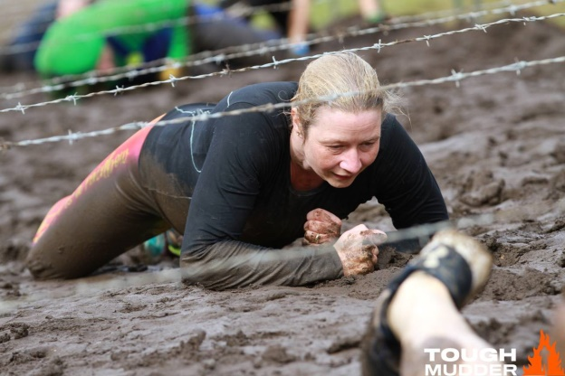

Christmas Party
Thursday 14th December
Springfield Country Hotel
6 pm until 10 pm

Buffet menu
Raffle
Christmas Quiz
£10 per person (payable on the day)

Please let Hannah know by 25th November if you can attend
Hannah.leadley@uhd.nhs.uk
Please bring a prize donation for the raffle
Springfield Country Hotel, Grange Road, Wareham, Dorset, BH20 5AL
www.thespringfield.co.uk 01929 552 177
Discounted rate for anyone wishing to stay the night (quote GO Group when bookin):
Standard Room & Breakfast £55.00 per person per night when sharing a double twin.
Single Occupancy supplement £20.00
Terms also include the full use of the Leisure Club & Spa

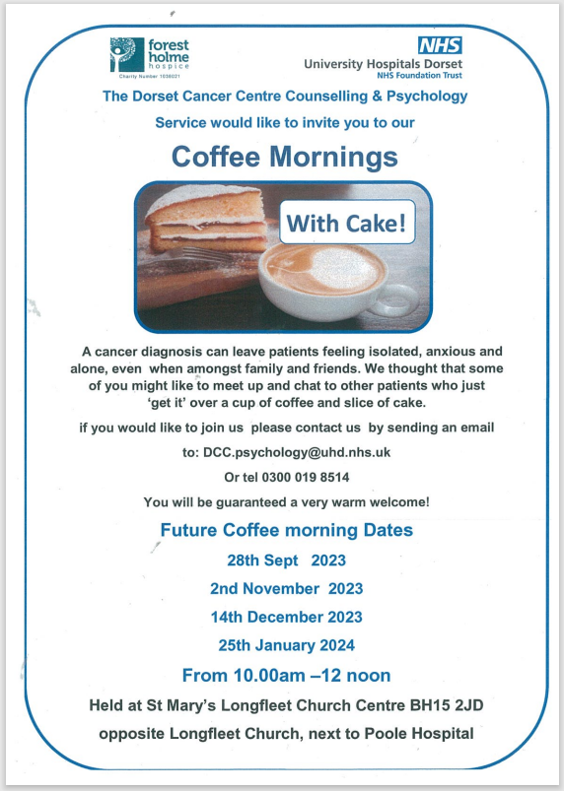

.
Fundraising/Donations
As you all know, we are not funded by the NHS but rely on donations. We are grateful for any donations and are always keen to make sure we can thank anyone donating so if any are made, please let us know by e mail

Bank account details are:

The Go Group
Sort Code: 09-06-66
Account number: 40906815 (Santander)
https://checkout.justgiving.com/c/2895426


Please gift aid if you are able – this allows us to claim back 25p for every £1 donated
If you are able to gift aid, please contact sarah.trickett@uhd.nhs.uk or hannah.leadley@uhd.nhs.uk for the form

Useful contacts
Salisbury
Paula Taylor – Clinical Nurse Specialist
E mail: Paula.Taylor25@.nhs.net
Tel 01722 425194

Bournemouth
Sarah Trickett – Clinical Nurse Specialist (GO Group Treasurer and Website manager)
Email Uppergi.Cns@uhd.nhs.uk
Tel 0300 019 4340

Emily Fowler - Clinical Nurse Specialist
Email Uppergi.Cns@uhd.nhs.uk
Tel 0300 019 4340

Janet Holmes -Cancer Support Worker
Email janet.holmes@uhd.nhs.uk
Tel 07584155744

Dorchester
Caroline Langley – Clinical Nurse Specialist
Email caroline.langley@dchft.nhs.uk
Tel 01305 255 710

Natalie Laing – Clinical Nurse Specialist
Email Natalie.liang@dchft.nhs.uk
Tel 01305 225 710

Steph Dukes – Cancer Support Worker
Email Stephanie.dukes@dchft.nhs.uk
Tel 01305 255 710

Poole
Emma Chester - Clinical Nurse Specialist (GO Group Secretary)
Email emma.chester@uhd.nhs.uk
Tel 0300 019 8739

Hannah Leadley - Clinical Nurse Specialist (outings co-ordinator and newsletter editor)
Email hannah.leadley@uhd.nhs.uk
Tel 0300 019 8739

Liv Cawthorne - Cancer Support Worker
Email Olivia.cawthorne@uhd.nhs.uk
Tel 0300 019 8739

https://thegogroup.org.uk

