
The GO Group
Dorset Gastrectomy and
Oesophagectomy Support Group

Autumn and Winter Newsletter 2020

Welcome to the autumn and Winter GO Group newsletter. I think it is safe to say that because of Covid-19 this year has been like no-other we have known with both within the NHS and the whole community. There have been very challenging and difficult times for many of our colleagues and patients. We hope you have managed to remain safe and although we have not been able to see each other you have all been in our thoughts.

Chairman’s Message (Terry Ingram)

Hello everyone I hope you are all keeping well in these strange and worrying times. Hopefully we shall be able to start our get together’s next year without too many restrictions .I would think the first one will be the A.G.M. which we shall organise as soon as it is safe to do so.
We will be organising some days out as soon as we get the green light for people meeting up again but in the meantime if you have any queries please do not hesitate to contact our wonderful nurses or any member of the committee and remember there’s no such thing as a stupid question.
I would like to wish you all a very merry Christmas and hopefully see you all soon into the new year.
Take care and stay safe
Terry and Bev

With more time being spent at home many of us have been doing more baking, here is one of Jane’s favourite easy recipes!

Easy Walnut Oatmeal cookies

3 cups (270g) rolled oats
1 1/3 cup (180g) S.R. Flour
½ teaspoon baking powder
½ teaspoon salt
¾ cup (180g) butter (room temperature)
1 cup (200g) dark brown sugar
½ cup (100g) white sugar
1 egg
¼ cup (60g) milk
1 teaspoon vanilla extract or paste
1 cup (100g) chopped walnuts

In a bowl beat butter, sugars egg milk and vanilla. Add oats flour, baking powder and salt
Mix until well blended. Add nuts and mix well. At this point refrigerate it (I often put half the dough in the freezer to use at a later date) put balls of the dough on baking parchment or greased trays. Walnut sized for smaller cookies: bigger sized for bigger cookies! Squash then down a bit then bake at 350F/180C for 12 – 15 minutes (depending on the size) cool on a wire rack then store in airtight tins or just eat them!
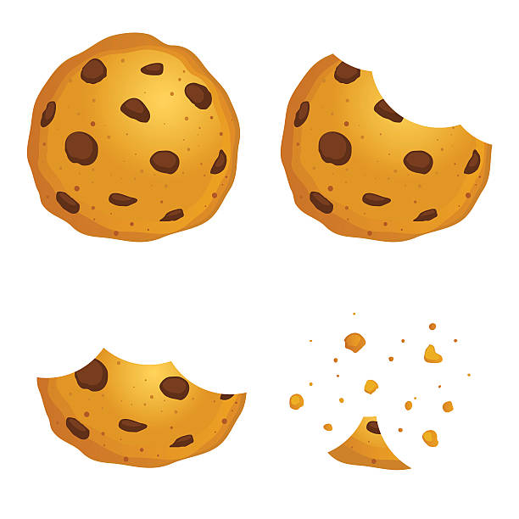

We will be in touch again next year hopefully with news of some events and outings and hope as the year develops to be able to return to a more normal way of life and look forward to seeing all our old members and welcoming some new ones too. As always your Specialist nurses are available for help and support – their contact details are on the following page – please note the change in e mail addresses and phone number for Sarah and Emily in Bournemouth.

Bournemouth  Sarah Trickett – Clinical Nurse Specialist  Emily Cowley – Clinical nurse Specialist  (Treasurer & GO Group Website manager)  Royal Bournemouth Hospital,  Castle Lane East,  Bournemouth, BH7 7DW  Tel: 0300 019 4340  E mail: sarah.trickett@uhd.nhs.uk  Emily.Cowley@uhd.nhs.uk | Poole  Emma Chester- Clinical Nurse Specialist  (GO Group Secretary)  Hannah Nolan – Associate Clinical Nurse Specialist  Dorset Cancer Centre,  Poole Hospital NHS Trust,  Longfleet Road  Poole, BH15 2JB  Tel: 01202 448739  E mail: emma.chester@poole.nhs.uk  hannah.nolan@poole.nhs.uk
Dorchester  Jane Wraight – Clinical Nurse Specialist  (Newsletter editor)  Caroline Langley – Associate Specialist Nurse,  Steph Dukes – Cancer Support Worker.  Upper GI CNS Office,  West Annexe,  Dorset County Hospital,  Dorchester, DT1 2JY  Tel 01305 255710  Email: jane.wraight@dchft.nhs.uk  Email: caroline.langley@dchft.nhs.uk  Email: Stephanie.dukes@dchft.nhs.uk | Salisbury  Lynne Constable – Clinical Nurse Specialist  Paula Taylor – Clinical Nurse Specialist  Salisbury Upper GI CNS  Salisbury District Hospital,  Odstock Road, Salisbury  Wiltshire, SP2 8BJ  Tel: 01722 425194  E mail: lynne.constable@salisbury.nhs.uk

The GO Group committee would like to wish all our members a safe and peaceful Christmas and a good new year.



