
The GO Group
Dorset Gastrectomy and
Oesophagectomy Support Group

Autumn and Winter Newsletter 2019

Emily’s Skydive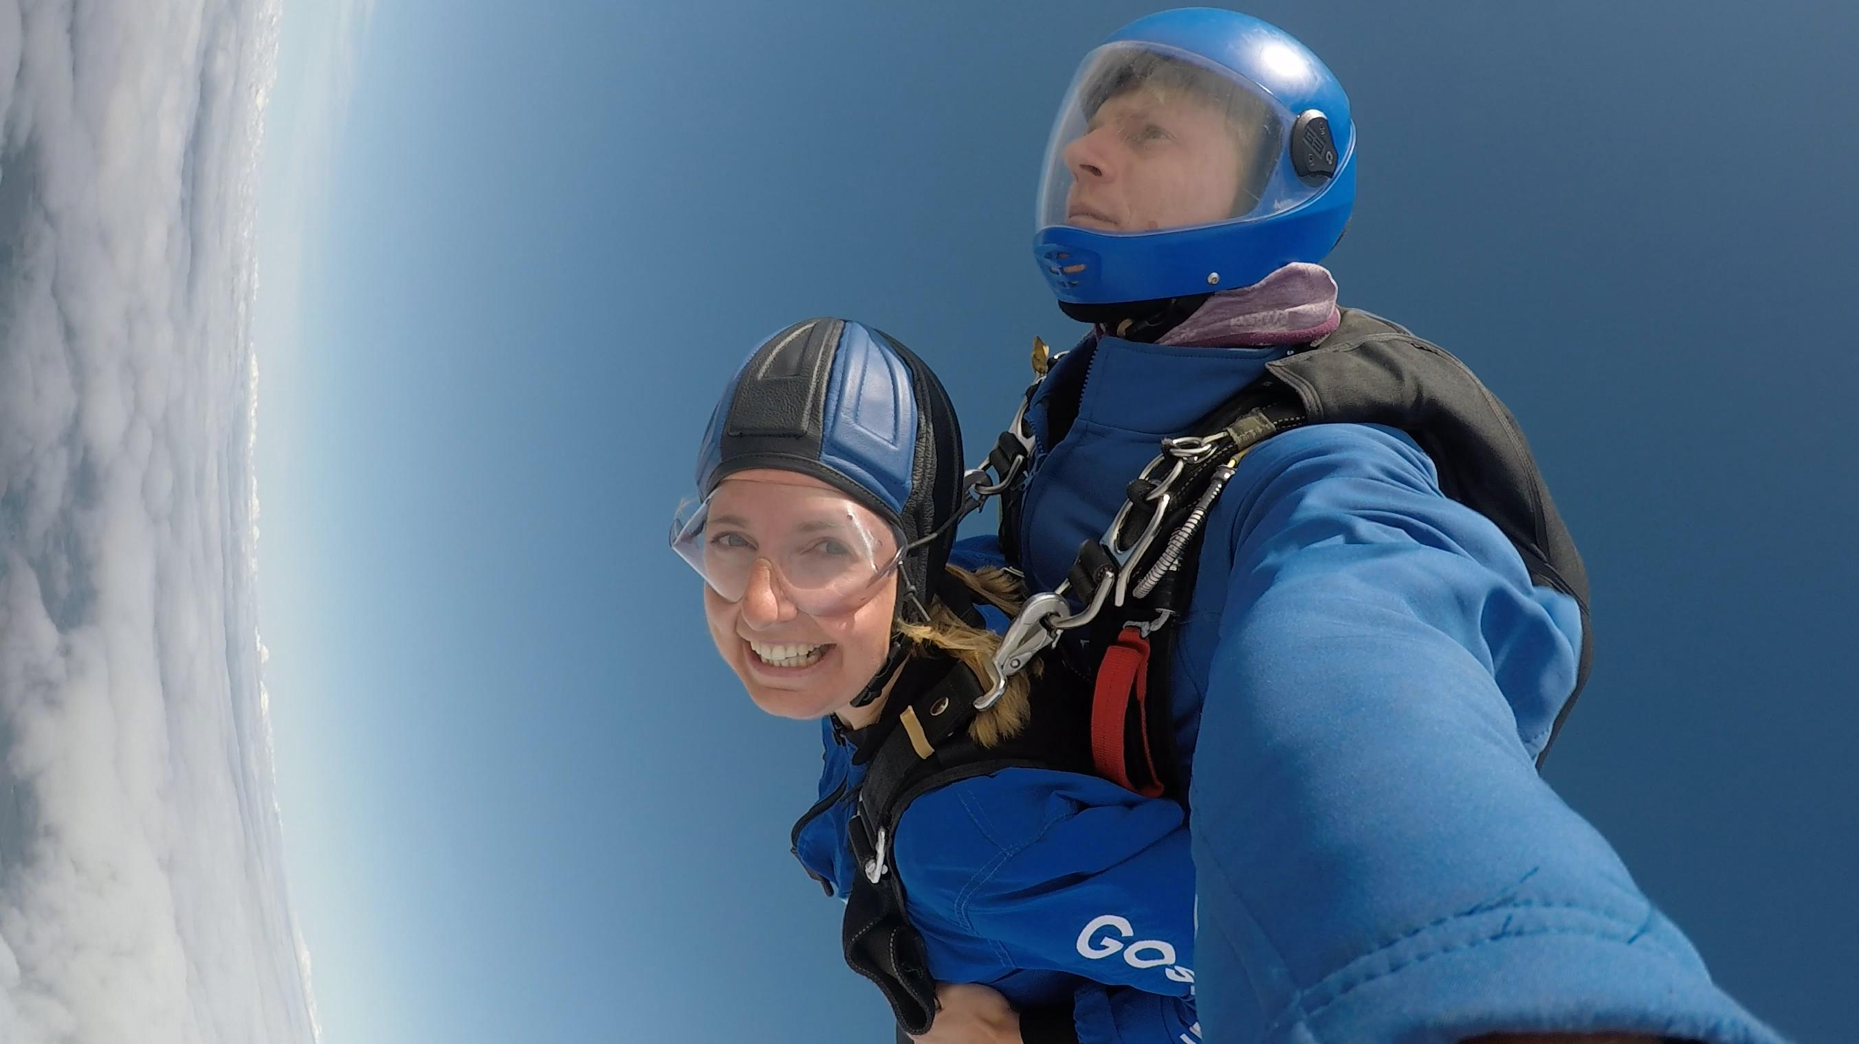

In the summer,Emily – our Bournemouth CNS raised £202 for the GO group by doing a skydive! We are all in awe of her bravery in jumping out of a plane and very grateful for her raising runds for the group. Amazing – well done Emily.

Message from our Chairman – Terry Ingram
Hello everyone - I hope you have all had a good summer. The trips this year have been wide and varied with a trip to Haynes Motor Museum, a boat trip to Wareham, an indoor picnic at Stourhead, a visit to the Blue Pool and lastly a trip to the Heavy Horse centre as well as a talk from Claire the dietician and Sam Hudspith the Macmillan Volunteer Services Manager about the new buddy system which they are hoping to implement and use our group as guinea pigs!
We had a mixed response to the trips with some very well attended and some not This may have been down to the weather as we did seem to have a few trips that coincided with a lot of rain. If there is a specific place you would like us to visit please let one of our CNSs know or any member of the committee and we will do our best to accommodate the trip in next year’s calendar.
I would just like to personally say a big thank you to all the committee for their hard work this year and look I forward to next year’s trips as well, -but first we have the Christmas party so if anyone would like to entertain us with a few jokes or a bit of singing in GO Groups got talent just let us know beforehand, if you need anything. We will have a microphone available and a CD player for backing tracks.
We have just been gift aid approved so any donations we receive we will be able to claim gift aid. This is great news for our group. Huge thanks to Sarah for all her efforts in sorting this out. If anyone has any ideas for fundraising just let us know and we will support you in any way we can as all monies go to keeping to costs of our days out down and pays for postage etc. so any donations are greatly appreciated.
It was lovely to see many of you at the Christmas party and hope to see you again at the AGM have a merry Christmas and a healthy New Year! - Terry and Bev.

Car Sharing
We have been made aware that there are some members who would like to attend some of the outings but are unable to because of lack of transport. If you would be prepared to offer a lift to any other members living in your area, please let us know via the booking form or your booking e mail to Sue. She can then let you know of anyone needing a lift. Similarly if you need a lift to any of the events, please do let us know again by contacting Sue Sweeny (contact details below). We are very keen that transport problems do not prevent our members from joining and benefiting from the meetings.

Sue is leaving
Sue Sweeny informed us at the Christmas party that she will be leaving her role as Cancer Support Worker at Poole Hospital. She will be sadly be missed from the hospital staff she works with and members of the GO group she has supported. However, Terry and other members Have encouraged her to continue to attend our meetings when she can and she gladly agreed. We wish her well.



Membership
Jane, Caroline and Steph in Dorchester will now share the role of membership secretary and keeps the database updated. Please don’t forget to let them know if you have any changes especially to your address and e mail. (Contact details on next page) We currently have over 180 members with one of our founding committee members having had his surgery 20 years ago.

E mail newsletters
We have asked before and are very grateful to all who already receive their newsletters by e mail rather than post as this reduces our stationary costs considerably. For those unable receive e mail we remain happy to post them.
Specialist Nurse Contact Details
As always, a reminder that your Specialist Nurses are here for you to provide help and support and are always pleased to hear from you.
Bournemouth
Sarah Trickett – Clinical Nurse Specialist
Emily Cowley – Clinical nurse Specialist
(Treasurer & GO Group Website manager)
Royal Bournemouth Hospital,
Castle Lane East,
Bournemouth, BH7 7DW
Tel: 01202 704340
Email Uppergi.Cns@rbch.nhs.uk.
Poole
Emma Chester- Clinical Nurse Specialist
(GO Group Secretary)
Hannah Nolan – Associate Clinical Nurse Specialist
Dorset Cancer Centre,
Poole Hospital NHS Trust,
Longfleet Road
Poole, BH15 2JB
Tel: 01202 448739
E mail: emma.chester@poole.nhs.uk
hannah.nolan@poole.nhs.uk

Dorchester
Jane Wraight – Clinical Nurse Specialist
(Newsletter editor)
Caroline Langley – Associate Specialist Nurse,
Steph Dukes – Cancer Support Worker.
Upper GI Office,
Abbotsbury Ward,
Dorset County Hospital,
Dorchester, DT1 2JY

Tel 01305 255710
Email: jane.wraight@dchft.nhs.uk
Email: caroline.langley@dchft.nhs.uk
Email: Stephanie.dukes@dchft.nhs.uk

Salisbury
Lynne Constable – Clinical Nurse Specialist
Paula Taylor – Clinical Nurse Specialist
Salisbury Upper GI CNS
Salisbury District Hospital,
Odstock Road, Salisbury
Wiltshire, SP2 8BJ
Tel: 01722 425194
E mail: lynne.constable@salisbury.nhs.uk


2019 / 2020 Events
With the exception of the March AGM, we will plan the 2020 events in the spring of next year. This will be discussed at the forthcoming AGM so please bring any ideas of venues and outings with you. All the finalised details will published in the spring and summer newsletter.

Thursday 26th March 1-4pm AGM and talk by Mr Cowie – Consultant Surgeon, Royal Bournemouth Hospital. This will be held at The Neptune Harvester. Undercliff Drive, Boscombe Pier, Bournemouth, BH5 1BN There is no charge for this meeting. Tea or coffee and refreshments will be provided. We anticipate this will be a very interesting talk by Mr Cowie who many of you will know. If you have any ideas for trips or outings for 2020, please bring them with you for the AGM.
Booking Form
Name(s) ____________________________________
I am able to offer a lift to other members Yes / No
Date | Event | Number Attending
March 26th | AGM and talk by Mr Cowie (Consultant Surgeon – Royal Bournemouth Hospital)
Please complete this form and return l to: Jane Wraight, Caroline Langley or Steph Dukes by post to:
Upper GI Office,
Abbotsbury Ward,
Dorset County Hospital,
Dorchester, DT1 2JY
Or e mail
Email: jane.wraight@dchft.nhs.uk
Email: caroline.langley@dchft.nhs.uk
Email: Stephanie.dukes@dchft.nhs.uk

