
The GO Group
Dorset Gastrectomy and
Oesophagectomy support group

Spring and Summer Newsletter 2018

Welcome to the spring and summer newsletter, as this is being written, the snow is blowing around outside but I hope that by the time you are reading this, spring and the promise of summer is well on the way.

AGM and Committee members.
We recently held our AGM at the Grove Hotel in Bournemouth, as usual, they looked after us very well and we enjoyed a delicious cream tea. The AGM and subsequent very interesting talk by Claire Stuckey – the Specialist Gastroenterology Dietitian from Royal Bournemouth Hospital provided was informative and answered many questions and concerns. We would like to thank her.
At the AGM, there were some changes in the committee offices: we were saddened that David Gay stepped down as Chairman – he has worked hard to maintain the on-going successful running of the support group and he and Audrey have

given a great deal of time and effort behind the scenes for the group – we would like to thanks them both for their efforts. We now welcome our new Chairman – Terry Ingram who many of you will already know we have already benefitted from Terry’s hard work and enthusiasm and are sure the group will continue to thrive with his support.
Mike Goodman has relinquished his role as Treasurer, we are grateful for his hard work in this role for the last four years and delighted he will remain on the committee. We are pleased that Sarah Trickett and Emily Cowley (Specialist nurses from Bournemouth) have taken on the role of treasurer and that Ian and Carolyn Cole have joined the committee
Another change is that we welcomed the newly appointed Macmillan support workers: Zoe Bond from Dorchester, Deborah Lynne Wilkinson from Bournemouth and Sue Sweeny from Poole to the committee. Zoe is going to share the role of membership secretary with Jane Wraight.

Patient representatives
We asked at the AGM if any of our members would be prepared to become a patient representative. This entails representing patients is a variety of ways: helping to review new patient information, attending meetings (around three or four a year) with the Dorset wide Upper GI Consultants and healthcare professionals responsible for ensuring we are meeting the national standards and helping to plan for the future. This is an important role; training and support for it will be provided. If you are interested, please contact your local specialist nurse.

Oesophageal Patient’s Association. (OPA) and Bed-Wedge pillow offer.
The OPA is a national charity which is similar to our own GO group. Although we are a separate group, we are pleased that they have offered us a microsite on their website. This is another way that our current newsletter and events can be viewed. For those of you able to access their web-site, there is some interesting information there. They have meetings across the country.
They currently have an offer for a price reduced bed wedge. We know that night-time acid reflux is a common problem. The OPA have teamed up with Putman pillows to provide their standard bed wedge - acid reflux for £26.40 rather than the normal price of £54.38. Delivery is also free. These are British made wedges that are more efficient than pillows in comfortably raising the torso to prevent acid reflux. To take advantage of this offer, call or email the OPA first and they will
give you a discount code. Call on 0121 7049860 or e mail on enquiries@opa.org.uk with the discount code, call Putnams on 01752 345678. Or e-mail on info@putnams.co.uk. Or visit www.putnams.co.uk/collections/bed-wedge/pillows/products/bed-wedge Note; on the website you will be able to enter the Discount Code on the checkout page.

Thank you’s
We are very grateful to Mrs Beryl Aplin, sadly her husband Allan died earlier this year, Beryl and Allan had been members of the support group since its beginning and attended many of the meetings together. Beryl gave the GO Group donations from Allan’s funeral. We would like to thank her for her generosity and on behalf of all the GO Group send our condolences.

In January Leon who is a Healthcare support worker in the Endoscopy department of the Royal Bournemouth hospital tackled a gruelling 24k SAS selection route over Pen Y Fan in the Brecon Beacons Wales. He did this to raise funds for the GO group and achieved a total of £55. He is pictured below with a GO Group shirt Tee shirt. 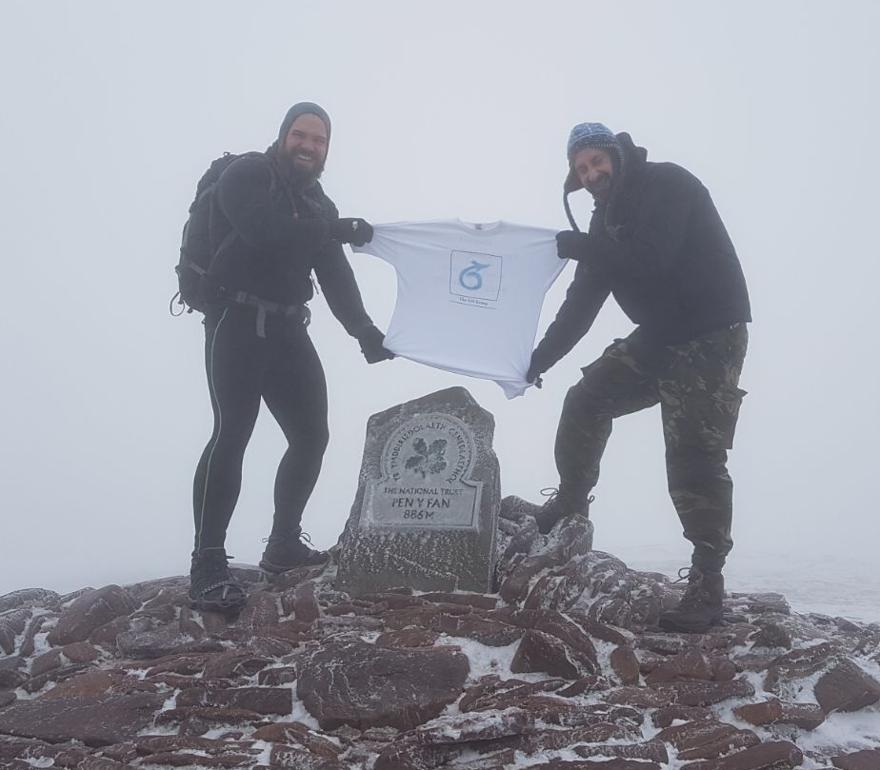
Small portion and Toilet cards.
We know that eating out and sometimes having rapid access to a toilet can be a problem for many of our members. We are still able to provide GO Group cards for our members to use to help in asking for a small portion when eating out or another card asking that due to a medical condition they need to have urgent access to a toilet. We are also now able to provide similar toilet cards made by Macmillan – the advantage of this is that they have the well-recognised and respected Macmillan logo and are a robust plastic with both a credit card sized card and a smaller card to attach to your keyring. These can be obtained either from your Specialist nurse or directly by Macmillan by phoning them on: free on 0808 808 00 00 (Monday - Friday, 9am - 8pm) or via their website. https://be.macmillan.org.uk/be/p-22493-generic-toilet-card.aspx You will need to login or create an account to order this free of charge.

Website
We are delighted that our website is now growing and that this and the previous newsletters are available online and as mentioned soon also on the OPA website. We are keen to continue to develop the site, if anyone has any comments or ideas for it, please contact Sarah Trickett. The web address is: https://thegogroup.org.uk

Macmillan Support workers.
We are pleased that in Poole, Bournemouth and Dorset County Hospitals there are newly appointed Macmillan Support workers. These are new posts which have been initially funded by Macmillan: although not qualified nurses they are becoming skilled in the aspects needed for their role, focusing on providing patient information and support, and recovery following treatment. Their roles complement the Specialist nurses and we anticipate that they will develop a strong relationship with the GO group. You may have already met Zoe and Deborah-Lynn at the AGM.

Specialist nurse Contact Details
As always, a reminder that your Specialist Nurses are here for you to provide help and support and are always pleased to hear from you.
Bournemouth
Sarah Trickett – Clinical Nurse Specialist
Emily Cowley – Clinical nurse Specialist
(Treasurer & GO Group Website manager)
Royal Bournemouth Hospital,
Castle Lane East,
Bournemouth,
BH7 7DW
Tel: 01202 704340
Email Uppergi.Cns@rbch.nhs.uk.

Poole
Emma Chester- Clinical Nurse Specialist
(GO Group Secretary)
Dorset Cancer Centre,
Poole Hospital NHS Trust,
Longfleet Road
Poole, BH15 2JB
Tel: 01202 448739
E mail: emma.chester@poole.nhs.uk

Dorchester
Jane Wraight – Clinical Nurse Specialist
(GO Group Membership Secretary and Newsletter editor)
Caroline Langley – Associate Specialist Nurse,
Upper GI Office,
Abbotsbury Ward,
Dorset County Hospital,
Dorchester,
DT1 2JY

Tel 01305 255710
Email: jane.wraight@dchft.nhs.uk
Email: caroline.langley@dchft.nhs.uk

Salisbury
Lynne Constable
Salisbury Upper GI CNS
Salisbury District Hospital,
Odstock Road, Salisbury
Wiltshire, SP2 8BJ
Tel: 01722 425194
E mail: lynne.constable@salisbury.nhs.uk

Please help us to reduce costs
To help us reduce our costs as much as possible, we would prefer to e mail rather than post the newsletters. If you are receiving this by post but are able to receive by e mail, please let us have your e mail address by e mailing jane.wraight@dchft.nhs.uk
Remember to update us if any of your details such as postal address or e mail address change. As the Support group is not a part of the NHS, even if your details are updated on your medical records, it will not transfer across to us.



Future events
At the AGM we planned several interesting, varied events for this year across north, south, east and west Dorset! We have tried to cater for as many interests as possible. As always, we ask that you either complete or post the booking form at the end of this newsletter or e mail to book your place. If you are then unable to attend, please let us know with as much notice as possible to enable us to book the right numbers of places and catering. Don’t forget to put the dates in your calander!

Thursday 24th May 12.00 Sammy Millers Motorcycle Museum 12.00- 4.30 pm Sammy Miller Motorcycling Museum Satnav Postcode BH25 5SZ Very well Sign Posted Bashey Cross Roads, New Milton. The Museum houses one of the finest collections of fully restored motorcycles in the world, including factory racers and exotic prototypes, with the collection constantly evolving as new bikes are acquired. This is a living museum, with almost every motorcycle in the museum in full running order. The Bashley Manor Tea Rooms in the Courtyard has Light lunches, Homemade Cakes and Cream Teas. There is also an Art Exhibition on during this visit, A Craft and Gift Shops, Alpacas, Donkeys, Goats and More. There will be a charge of £5 per person for this visit.
Wednesday 11th July at Sculpture by the lakes. Meet at 12.00 in the restaurant then wander around the lakes and sculptures. Bring your cameras. Address Pallington Lakes, Tincleton. DT2 8QU. No dogs allowed on site. Cost of £5.00 per person.
Sunday 19th August Sunday lunch and quiz at the Pulpit Inn, Portland Bill. Portland, DT5 2JT Meeting at 12.00 Paying for own food and drinks. Good food, lovely views and photo opportunities.
Friday 21st September Castletown D Day Centre Meeting at 12.00 to explore and look around then meeting at 3.00 for a cream tea. Castletown D-Day Centre is an authentic recreation of the busy wartime dockyard on the Isle of Portland, from which in 1944, thousands of American troops of the 5th US Corps and the US 1st infantry, embarked, bound for the heavily defended beaches of Nazi occupied France. Address: Castletown, Portland, DT5 1BD Easy to spot as they have a Sherman Tank parked outside! Cost of £5.00 per person.
Wednesday 3rd October Cranbourne Garden Centre, Meet at 1.00pm for those wishing to tour the gardens then at 3.00pm for another interesting a talk by Dr Charlie Gordon (Consultant Gasteronterologist at Royal Bournemouth Hospital) followed by a cream tea at 4.00pm Cranborne Garden Centre, Cranborne, Dorset BH21 5PP. There is no charge for this event.

Wednesday December 12th Christmas Party The Grove Hotel, 2 Grove road, East Cliff, Bournemouth BH1 3AU. As we had such an enjoyable time for the past two years, we are again going to The Grove Hotel in Bournemouth for our annual Christmas party. Meeting at 6 pm We will have the full use of the conservatory and lounge area to meet and have drinks. A finger buffet will be available at 7.00pm in the dining room, followed by the traditional raffle.

Name(s) ______________________________________________________

Event and time | Attending Yes or No | Number
24th May Sammy Millers Motorcycle Museum | Yes / No
11th July at Sculpture by the lakes | Yes / No
19th August Sunday lunch and quiz | Yes / No
21st September Castletown D Day Centre | Yes / No
3rd October Cranbourne Garden Centre | Yes / No
12th December Christmas Party | Yes / No

Please complete this form and return by e mail to jane.wraight@dchft.nhs.uk or by post to:
Jane Wraight, Upper GI CNS, Upper GI Office, Abbotsbury Ward, Dorset County Hospital, Dorchester, Dorset, DT1 2JY

