
The GO Group
Dorset Gastrectomy and
Oesophagectomy support group

Spring and Summer Newsletter

Welcome to the Spring and Summer edition of the GO group newsletter. As usual the committee have been working hard to organise several exciting events for this year and hope that many of our members both old and new will be able to join us.
Terry’s review of 2016
The Christmas party held at the Grove Hotel was another success with more people attending than before. I hope you all enjoyed yourselves and are looking forward to the trips and events in 2017.
The committee have been working hard to try and sort out the trips and have them spread about all over Dorset rather than in one area. Full details are in this newsletter.
I will be organizing a Sunday lunch again this year at the Virginia Ash at Henstridge on Sunday 6th August. This will possibly be limited in numbers so will be on a “first come first served” basis so if this is something you would like to come to, please make sure you get you booking form completed early! If anyone requests a place and they are already full, we will let you know
A new extra event this year will be the G.O. rally held at the Red Lion, Winfrith Newburgh between Wool and Dorchester on sat 16th September.
This is a biking weekend Bev and I organize with a bike show in the afternoon and a band and raffle in the evening,
Anyone from the group is more than welcome to come along and see what we get up to and will be made most welcome. For more information contact me (e-mail address on booking form.) Please all remember to bring your cameras along as we will once again be holding the photographic competition so will need your snaps of the different visits.
That’s all for now take care and see you all soon
Terry and Bev Ingram (Committee members)

Photo Competition 2017
As mentioned above, we plan to have another photo Competition for 2017. Any of our members can enter any photo taken at any of the 2017 events so don’t forget your cameras! Judging and prize giving will be at the Christmas party.

Badges
Many of you already have a GO group badge. These are free to members. They have been particularly helpful at identifying group members especially when visiting places where there are also general public or other groups. We would ask that you keep your badges safely and wear them to any event. If you have lost it, we have a small supply which we bring to most events.

Specialist Nurse Changes
After many years of hard work and service, Mike Goodman (Bournemouth Specialist Nurse) has started his well-earned retirement. Mike was one of the three CNSs who founded the support group over ten years ago. We are delighted to be able to report that he is continuing his involvement with the GO group remaining on the committee as treasurer and attending many of the forthcoming events. Working alongside Sarah Trickett in Bournemouth we are pleased to welcome a new Specialist Nurse - Emily Cowley we look forward to welcoming her to the group.
There is also exciting news in Poole hospital: we are sure you will all be delighted to know that Emma Chester (Poole Specialist Nurse) is expecting a baby in June. She will be going on maternity leave but plans to attend many of the GO group events during the year (we are all looking forward to meeting the baby.) Emma’s maternity leave will be covered by Gemma Bryant.

Happy Birthday and thank you.
We were all very grateful to Carolyn Cole who last year celebrated a significant birthday and generously asked her family and friends to make a donation to the GO group rather than receive presents. She presented a cheque for £430. To the GO Group and we are sure you will all want to thank her for her generosity and wish her a belated many happy returns. She is pictured below handing her cheque over to our Chairman David and Mike at the AGM.
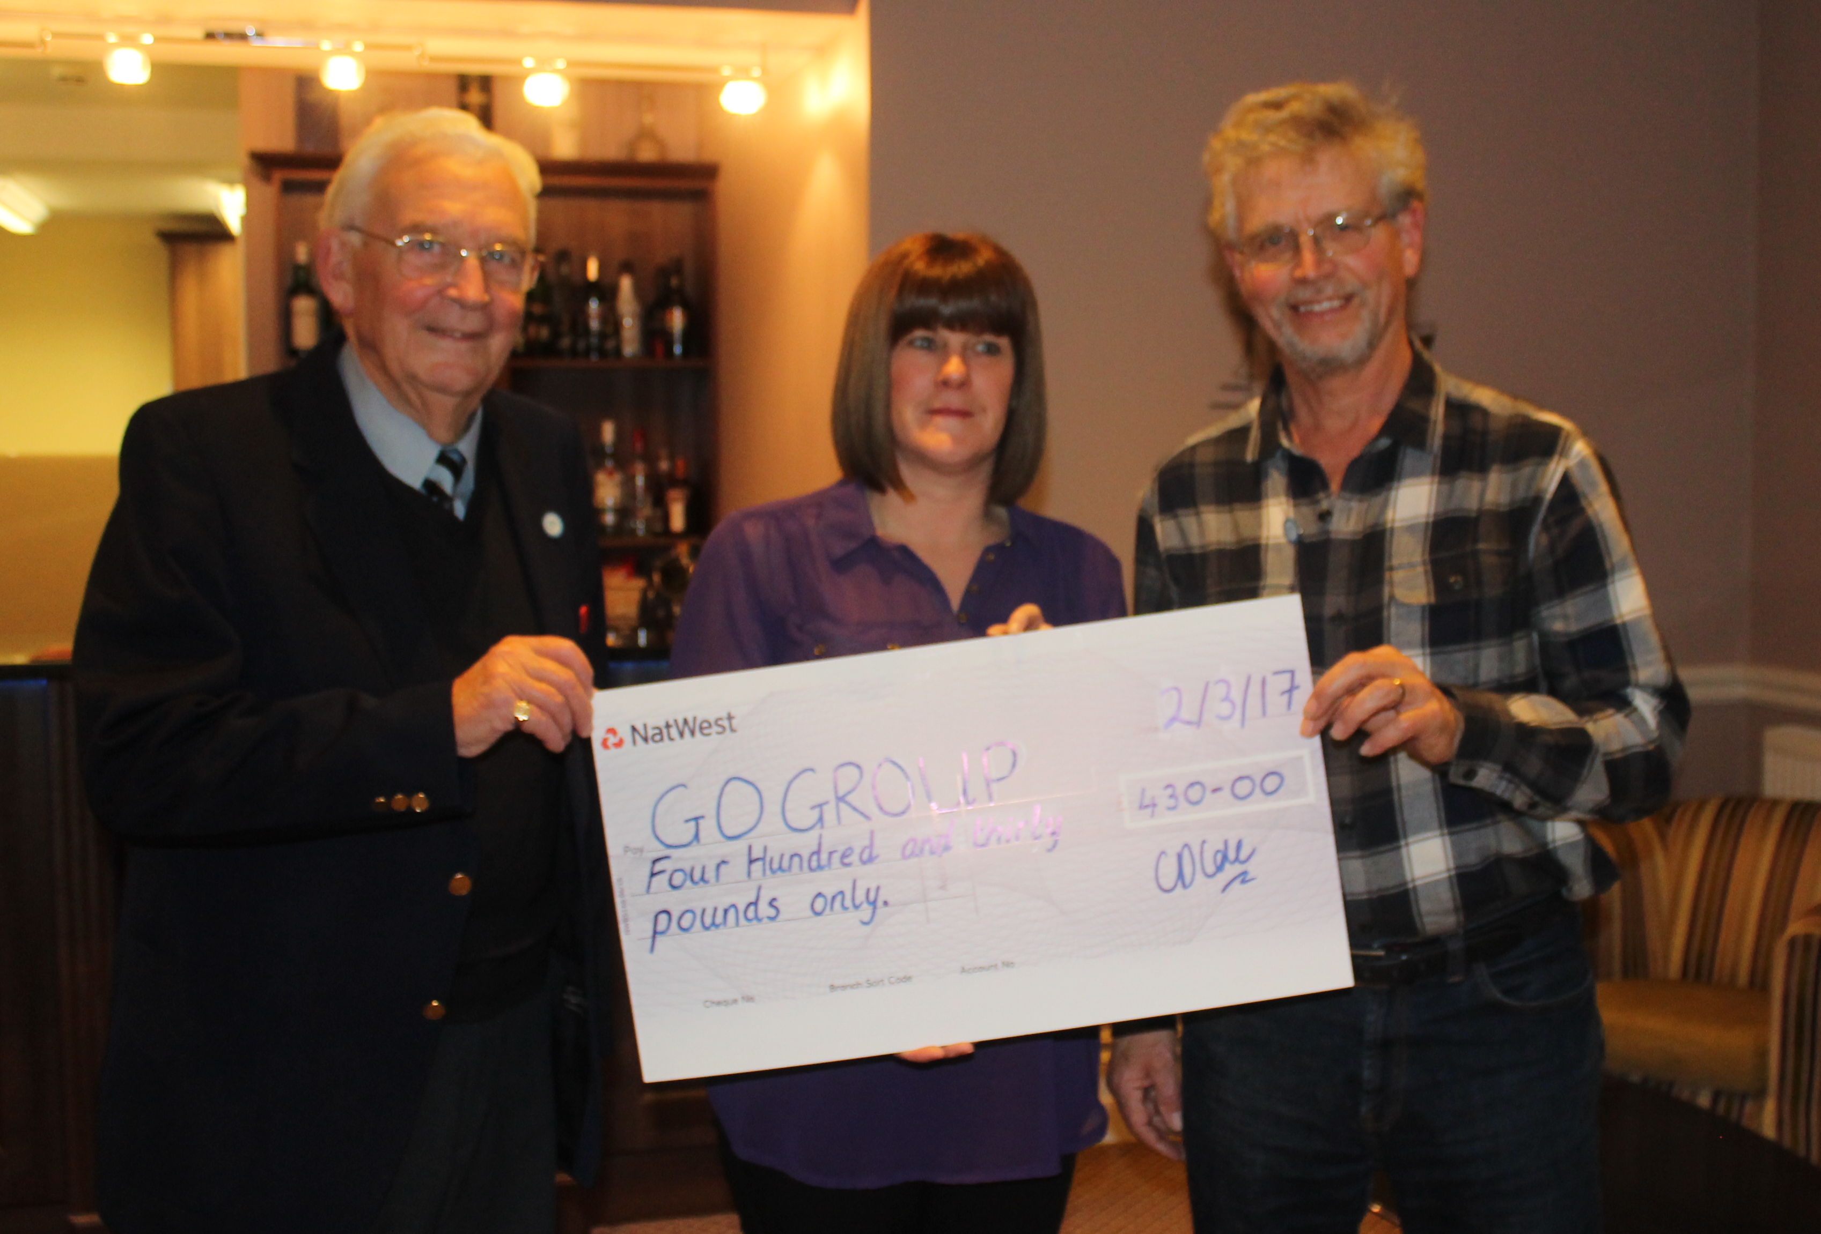
Small portion cards
We have a supply of GO group “small portion cards” These are business card sized and have the GO group logo on one side and on the other the wording, ”Due to a medical condition I am unable to eat normal portions of food. Please provide me with a small portion. Thank you”. Several of our group members find these useful when eating out and keep them in their wallet or purse. If you would like one, please contact your Specialist Nurse or ask at any event.

Website
We are delighted that our website is now growing and that this and the previous newsletters are available online. We are keen to continue to develop the site, if anyone has any comments or ideas for it, please contact Sarah Trickett. The web address is: https://thegogroup.org.uk

Specialist nurse Contact Details
As always, a reminder that your Specialist Nurses are here for you to provide help and support and are always pleased to hear from you.
Bournemouth
Sarah Trickett – Clinical Nurse Specialist
(GO Group Website manager)
Emily Cowley – Clinical nurse Specialist
Royal Bournemouth Hospital,
Castle Lane East,
Bournemouth,
BH7 7DW

Tel: 01202 704340
Email sarah.trickett@rbch.nhs.uk
Emily.cowley@rbch.nhs.uk

Poole
Emma Chester- Clinical Nurse Specialist
(GO Group Secretary)
Gemma Bryant - Clinical nurse Specialist (Covering Emma’s maternity leave)
Dorset Cancer Centre,
Poole Hospital NHS Trust,
Longfleet Road
Poole, BH15 2JB
Tel: 01202 448739
E mail: emma.chester@poole.nhs.uk
Gemma.bryant@poole.nhs.uk

Dorchester
Jane Wraight – Clinical Nurse Specialist
(GO Group Membership Secretary)
Caroline Langley – Associate Specialist Nurse,
Upper GI Office,
Abbotsbury Ward,
Dorset County Hospital,
Dorchester,
DT1 2JY

Tel 01305 255710
Email: jane.wraight@dchft.nhs.uk
Email: caroline.langley@dchft.nhs.uk

Salisbury
Lynne Constable
Salisbury Upper GI CNS
Salisbury District Hospital,
Odstock Road, Salisbury
Wiltshire, SP2 8BJ
Tel: 01722 425194
E mail: lynne.constable@salisbury.nhs.uk
Fund raising

As mentioned earlier in this newsletter, the GO group is not formally funded in any way. If any of our members would like to do any fundraising such as a coffee morning for friends and family or any sponsored events this would help to increase our finances. Your Specialist nurse would be happy to talk to about this.
Contact details
To help us reduce our costs as much as possible, we would prefer to e mail rather than post the newsletters. If you are receiving this by post but are able to receive by e mail, please add your e mail address to the booking form or e mail jane.wraight@dchft.nhs.uk

2017 events
Please note, it is essential we have accurate numbers of members attending in order to book for appropriate numbers – Please complete and return you’re booking form by 12th May.

Thursday 25th May 2.00pm Durlston Country Park National Nature Reserve near Swanage.
Satnav postcode is BH19 2JL. This is one of the best sites in Britain for wildlife, along with spectacular sea views and a fascinating Victorian history. Join a Ranger for a gentle stroll through Durlston’s spring meadows. The walk will start from the Learning Centre at 2pm and will be mainly over level, easy ground, finishing at Durlston Castle at around 3.30pm. There is no charge for this event. Members can purchase their own refreshments in the café at the castle. We will also be holding a fundraising raffle at this event, any prizes will be appreciated. For more information on Durlston Country Park, visit www.durlston.co.uk

Tuesday 11th July 12.00. Wilton House, Salisbury.
Satnav postcode is SP2 0BJ. Wilton House is set in the beautiful Wiltshire countryside and home to the Earls of Pembroke since the 1540s, Wilton House and the grounds offers a wonderful day out for all the family.

Stroll around the House with its 17th century interiors and world famous art collection by renowned artists such as van Dyck, Pieter Brueghel, Rembrandt van Rijn and Richard Wilson. With over 22 acres of parkland and gardens, bordered by the rivers Wylye and Nadder, the Grounds are perfect for visitors to explore or to relax in and have a picnic. We will meet at in the car park at 12.00 and enjoy a 90 minute guided tour of the house at 12.30 We would suggest that our members bring a picnic to enjoy afterwards although there is The Palladian Restaurant, set near the entrance to the Grounds, with views of the parkland if you to prefer to purchase your refreshments. There will be a cost of £ 10.00 including entry and a tour of the house.

Sunday 6th August 12.30 Sunday lunch at Virginia Ash at Henstridge.
Satnav BA8 0PL (5 miles from Sherborne) This will be an opportunity for our members to get together over Sunday lunch. We are aware that some of our younger members who work find it difficult to come to meetings or events on a weekday. This will be an opportunity to relax and catch up with each other. Members will purchase their own food and drinks. Further information about this can be obtained by contacting Terry and Bev Ingram via e mail on: benandpatch@aol.com

Friday 29th September 2.00 pm The Tank Museum Bovington.
Satnav postcode BH20 6JG. Come face to face with over 300 huge military machines that have seen action in the major conflicts of the last century. Hear amazing true stories from the soldiers who fought in them, in awe-inspiring provoking exhibitions. The Tank Museum is open to 5.00pm we will meet at 4pm in the restaurant for a cup of tea and a chat to finish off the visit. There is a large restaurant with a variety of hot and cold food, or just tea and cake for our members to purchase. There will be a charge of £5.00 per person for this event.

Monday 6th November 11.30 - Poole Pottery.
Satnav postcode BH15 1HJ Meeting at 11.30 then watching a demonstration at 12.00. Following this members are free to purchase tea or coffee in café for lunch at 1.00pm. To enable us to be seated together, seats will be reserved so please indicate on the booking form if you would like a seat reserved for you. There, will then be time to explore the two floors of pottery, kitchenware and cook shop etc. The address for Poole Pottery is: Poole Pottery Studio, The Quay, Poole, Dorset. There is no cost for this but members can purchase their own refreshments. There is a multi-storey car park directly opposite the pottery.

December 13th 6.00pm Christmas Party at The Grove Hotel
Satnav postcode BH1 3AU. 2 Grove Road, East Cliff, Bournemouth. As we had such an enjoyable time last year, we are again going to The Grove Hotel in Bournemouth for our annual Christmas party. Meeting at 6 pm We will have the full use of the conservatory and lounge area to meet and have drinks. A finger buffet will be available during the evening in the dining room, followed by the traditional raffle.

We are always keen to hear from our members about any ideas they have for future outings and events, please let any of the committee or you Specialist nurse know of any that may be suitable.
Booking form

Name(s)_______________________________________________________________________

E mail Address: _________________________________________________________________

National Trust Member Yes/No

Event | Number attending | Details
25th May 2.00pm Durlston Country Park |  | ----------
11th July 12.00. Wilton House, Salisbury. |  | House tour  Yes / No
6th August 12.30 Sunday lunch at Virginia Ash at Henstridge. |  | ----------
29th September 2.00 pm The Tank Museum Bovington. |  | -----------
6th November Poole Pottery Monday 6th November |  | Lunch reservation  Yes / No
13th December Christmas party at The Grove Hotel |  | -----------

Please Make a note in your diary or calendar of which events you are going to attend and then e mail to Jane.wraight@dchft.nhs.uk or post completed form by May 12th 2017 to:
Jane Wraight, Upper GI Office, Abbotsbury Ward,
Dorset County Hospital, Dorchester, DT1 2JY

If this is your first GO Group newsletter, we hope you have enjoyed reading it. We know that some people are happy to continue to receive these twice yearly newsletters and others are not. If you would prefer not to receive further copies, please contact Jane and ask to be removed from the database of members. Thank you

